**Get Request to get specific Repository:**

Go to the request and give the URL as given below

<https://api.github.com/repos/:owner/:repos>

And give the Owner name of the repository and Repository we want to fetch.

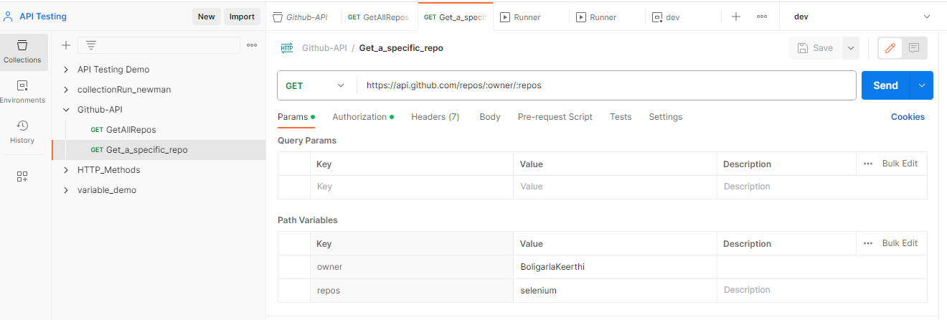

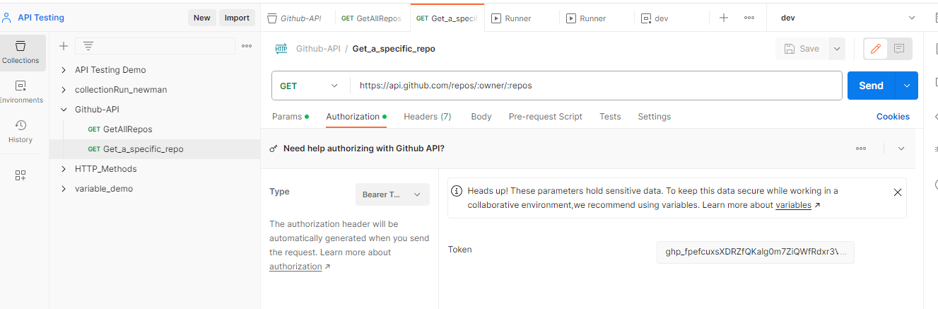

And send the request Api fetch the Information about that repository.

